User Role: Admin - juliustolentino.diamond@gmail.com
User Role: Registrar - hbaki386@gmail.com
User Role: Dean - juliustolentino0101@gmail.com
User Role: Faculty - juliusexample@gmail.com
User Role: Student - crowsnight379@gmail.com

LIST OF ACCOUNTS TEST
lmstest.mel01@gmail.com
Lmstest01 -USED AS STUDENT

daniel.mitchell9412@gmail.com
Qollabai2026

luna.akirapogi@gmail.com
Qollabai2026

matthewcauso@gmail.com
Qollabai2026

User Role: Admin - juliustolentino.diamond@gmail.com

- Created New User login(Severity: s2 High)
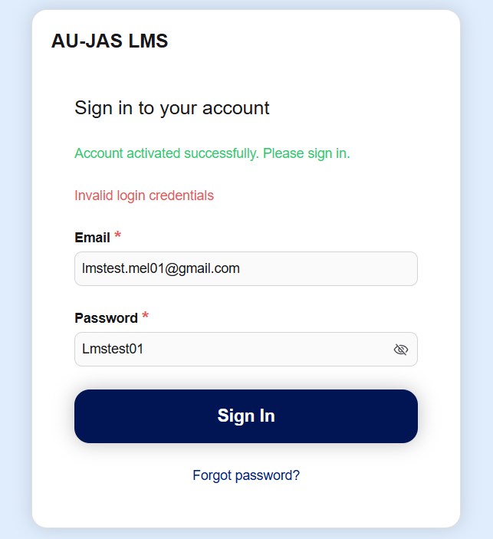

Errors: | Created new usera (student acc) cannot access the lms.
Suggestion:
Bug Type: | Functional
Module: | Log in

- Dashboard (Severinity: S2 High)

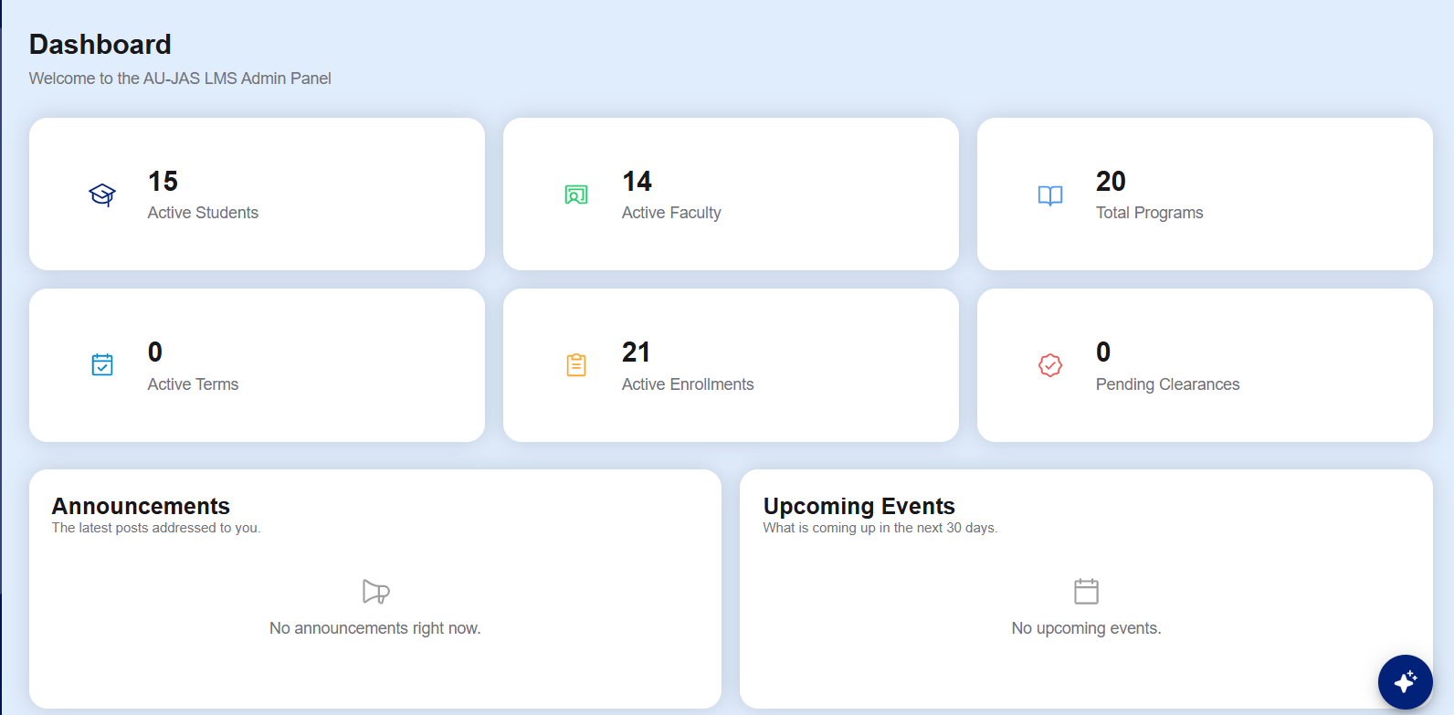

Errors: | Total programs, active enrollments, pending clearances are not working whenever I click them.
Bug Type: | Functional
Module: | Dashboard

- Loading (Severity: S3 Medium)
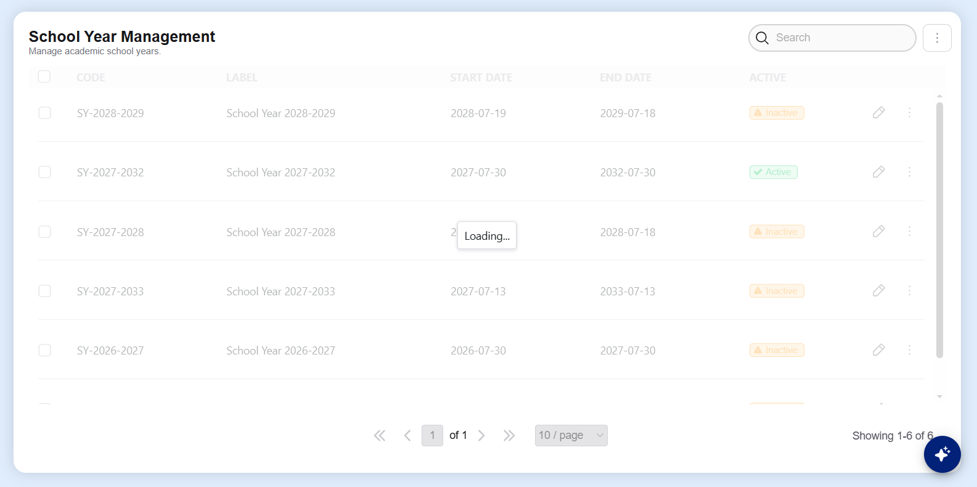
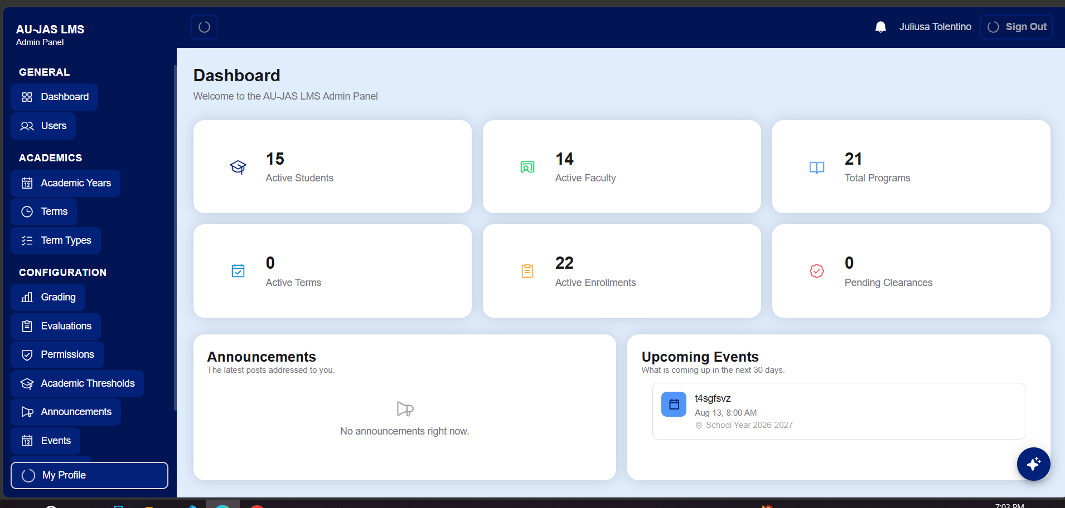
Errors: | Need to refresh the page before stopping the loading or stop freezing.
Bug Type: | Performance
Module: | Academic years and dashboard

- Term Type loading (Severity:S3 Medium)
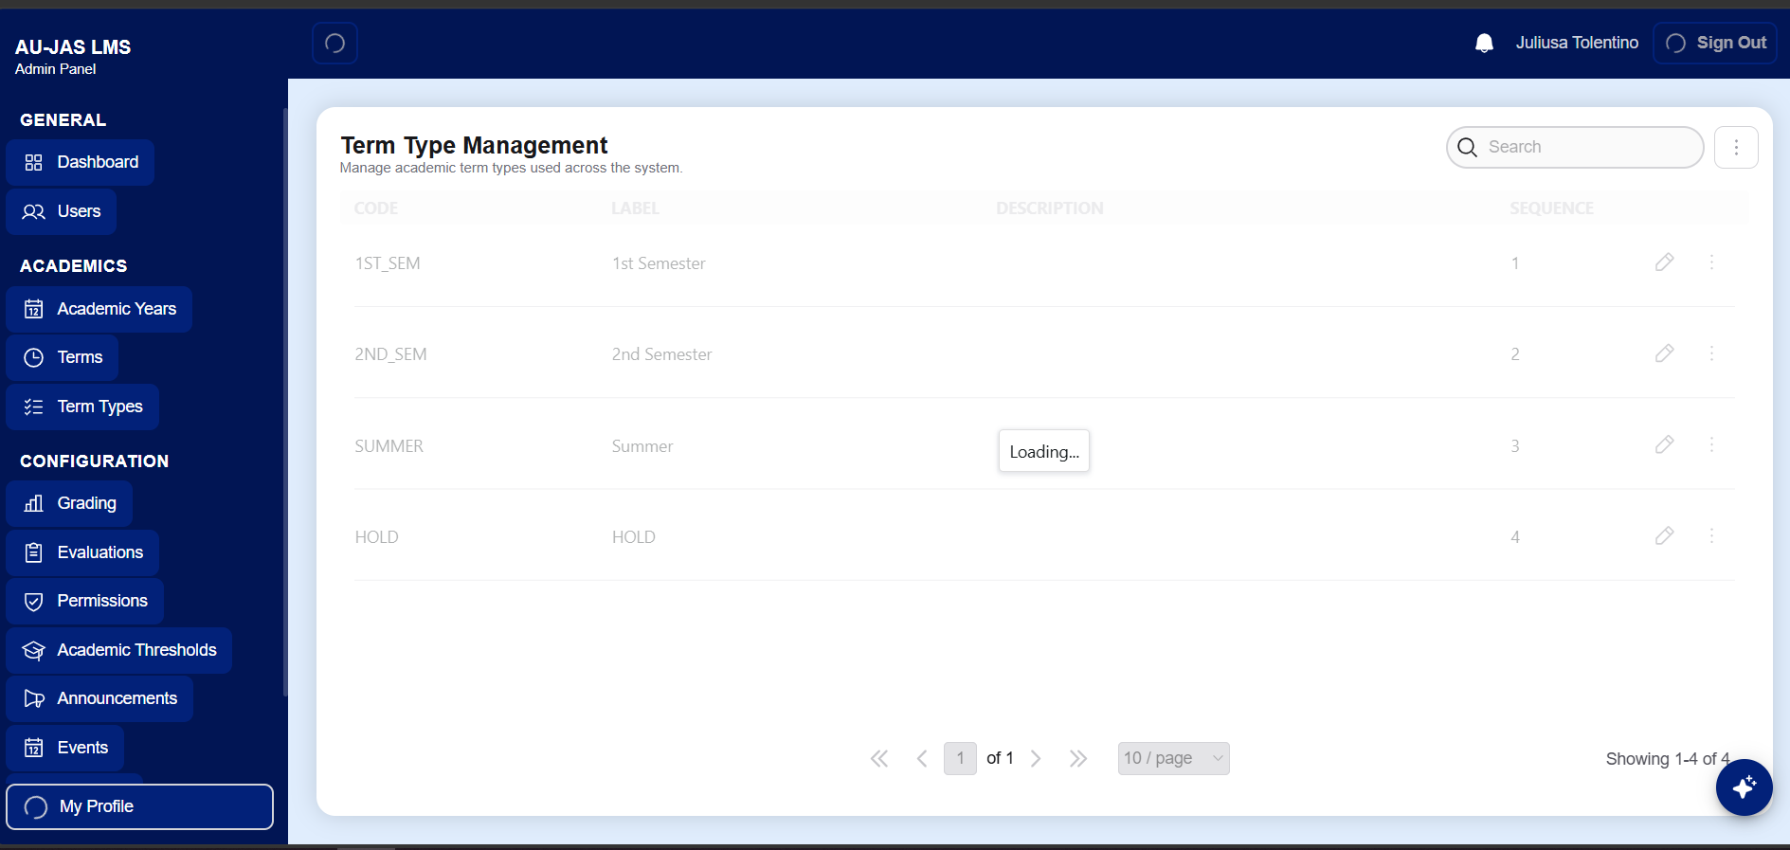
Errors: | Need to refresh the page before stopping the loading or stop freezing.
Bug Type: | Performance
Module: | Term Types

- chatbox (Severity:S3 Medium)
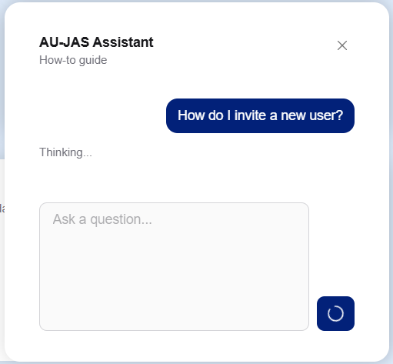
Errors: | Slow response takes minutes to respond.
Bug Type: | Functional
Module: | Ai chabotbox

- Chat (Severity: S3 Medium)
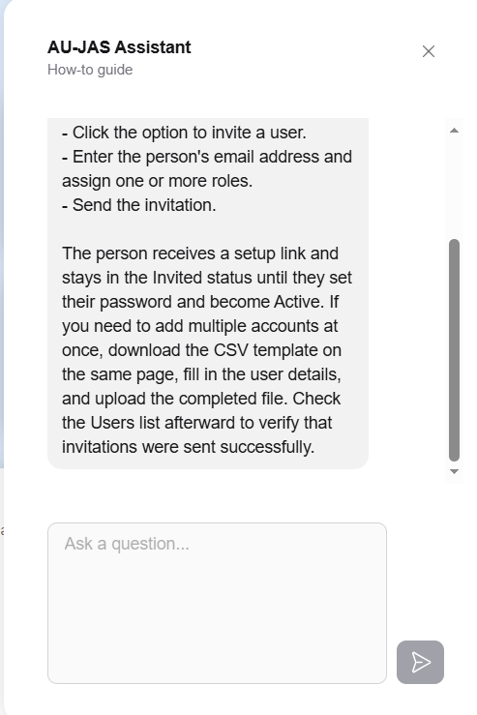
Errors: | I can’t use chatbox again because of the option ( “How do I invite users?”, “how do i open a new term?”, “what do academic thresholds change?” ) are not visible after the chatbox responds.
Suggestion: | After the AI chatbox responds, there’s still the option to choose to ask the chatbox.
Bug Type: | Performance
Module: | Dashboard

- Evaluation (Severity: s3 Medium)
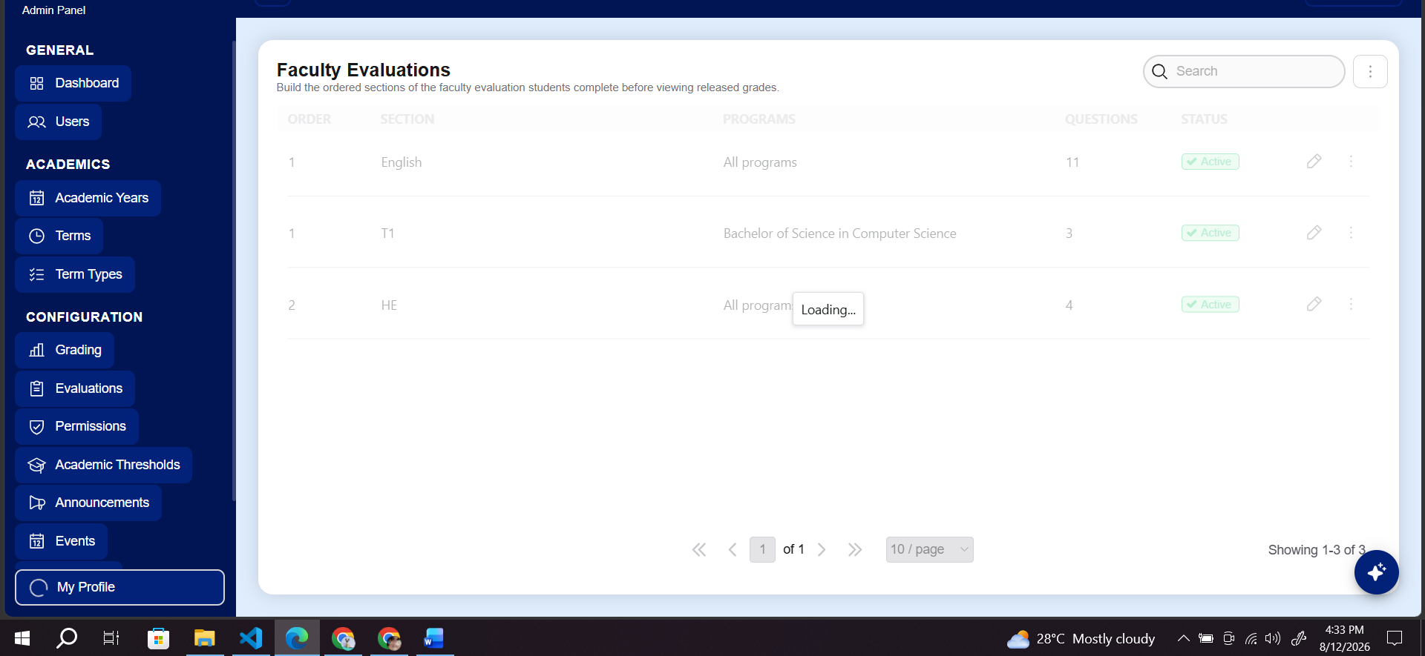

Errors: | Slow loading.
Suggestion:
Bug Type: | Performance
Module: | Faculty Evaluations

- Permission (Severity: s3 medium)
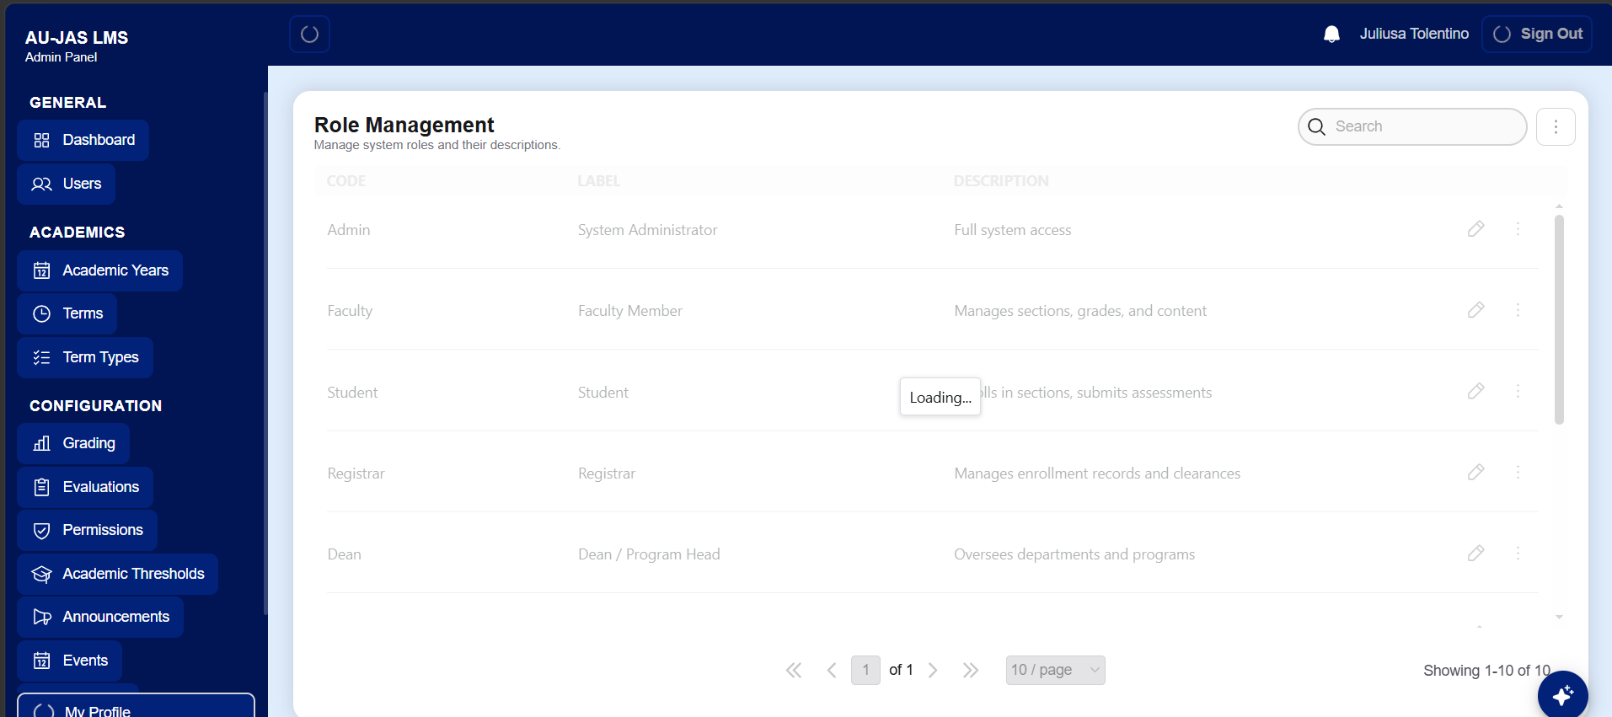

Errors: | It loads slowly. Neeed to refresh the page.
Suggestion:
Bug Type: | Performance
Module: | Role Management

- My profile (Severity: s1 Critical)
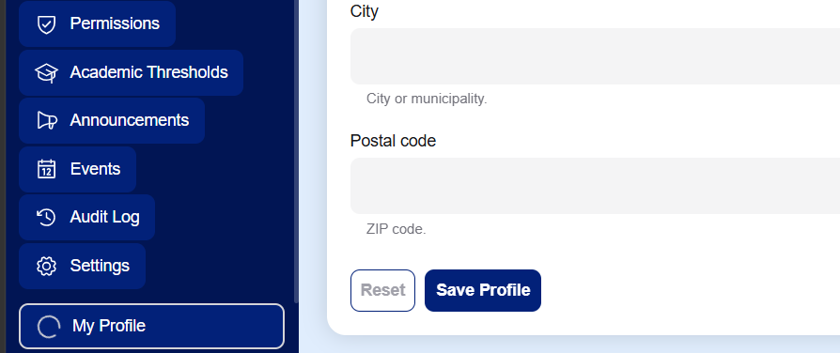
Errors: | .cannot click save profile and no change
Suggestion:
Bug Type: | Functional
Module: | Profile

- Announcement ((Severity:s1 Critiacal )
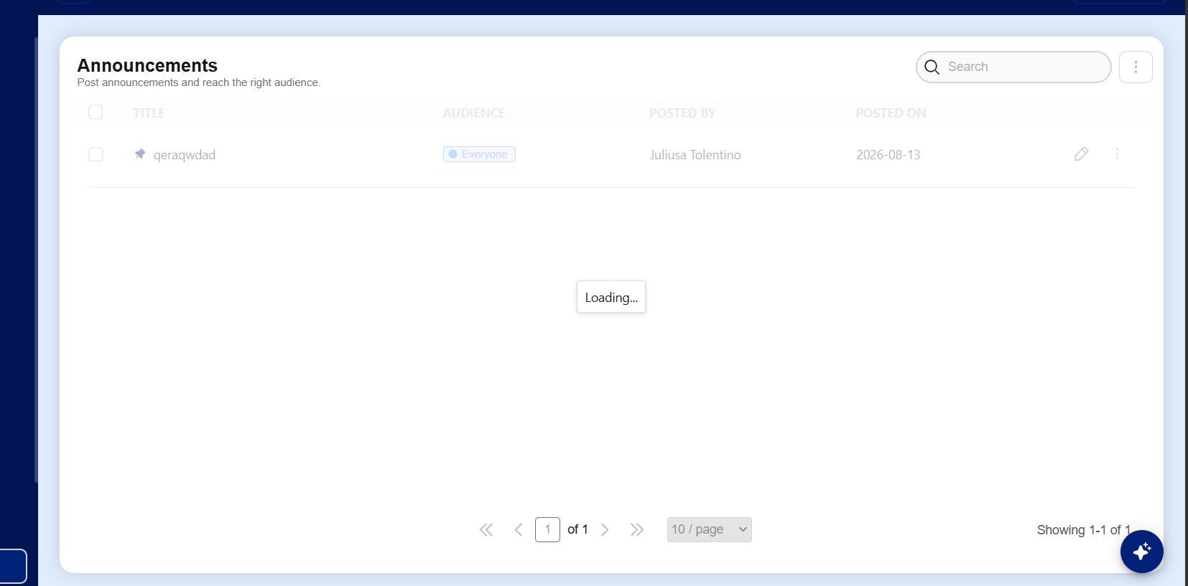
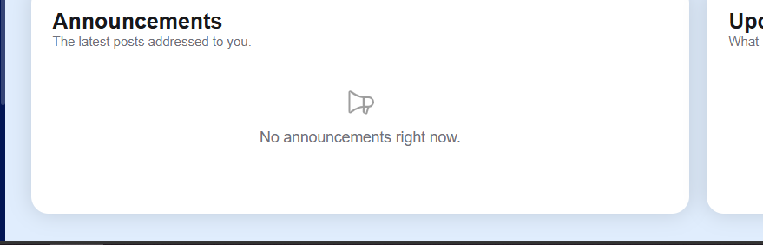
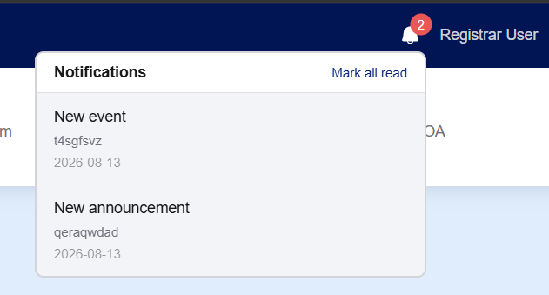

Errors: | - Slow loading  - it didn’t show on the dashboard to every users but it showed on the notification button.
Suggestion:
Bug Type: | Performance
Module: | Announcement

User Role: Registrar - hbaki386@gmail.com

- DASHBOARD Upcoming Event (Severity: s2 high)
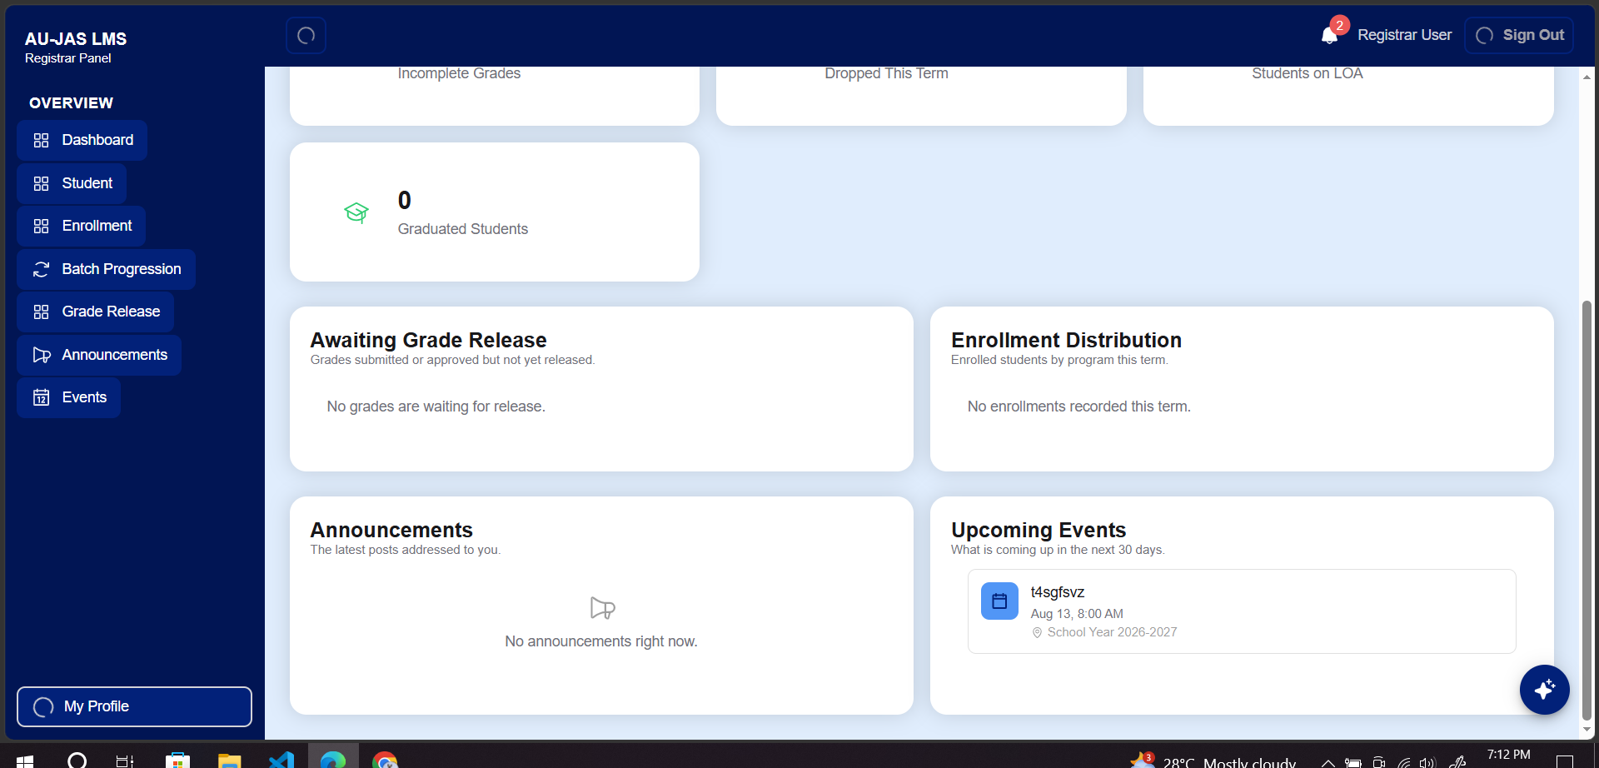
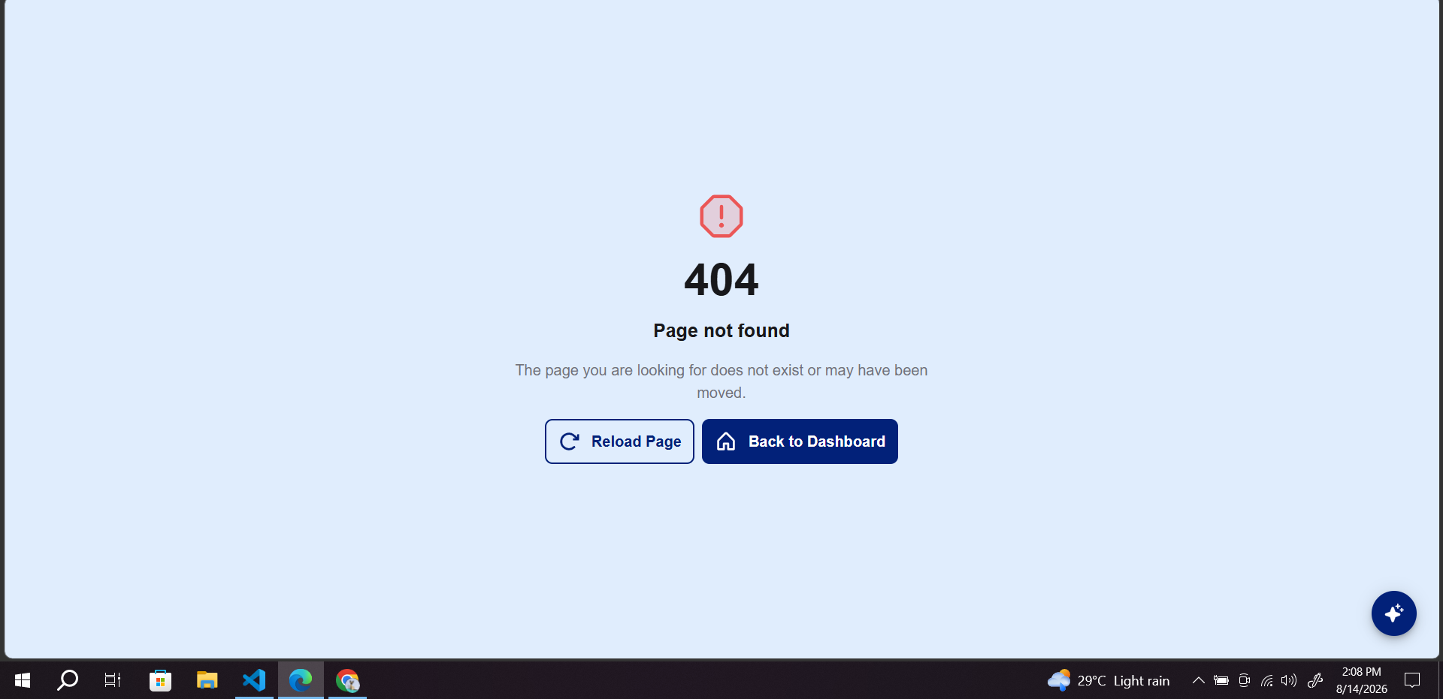

Errors: | Cannot click on the event, when i click on the notification bell it shows a page not found.
Suggestion:
Bug Type: | performance
Module: | events

- Student (Severity: )
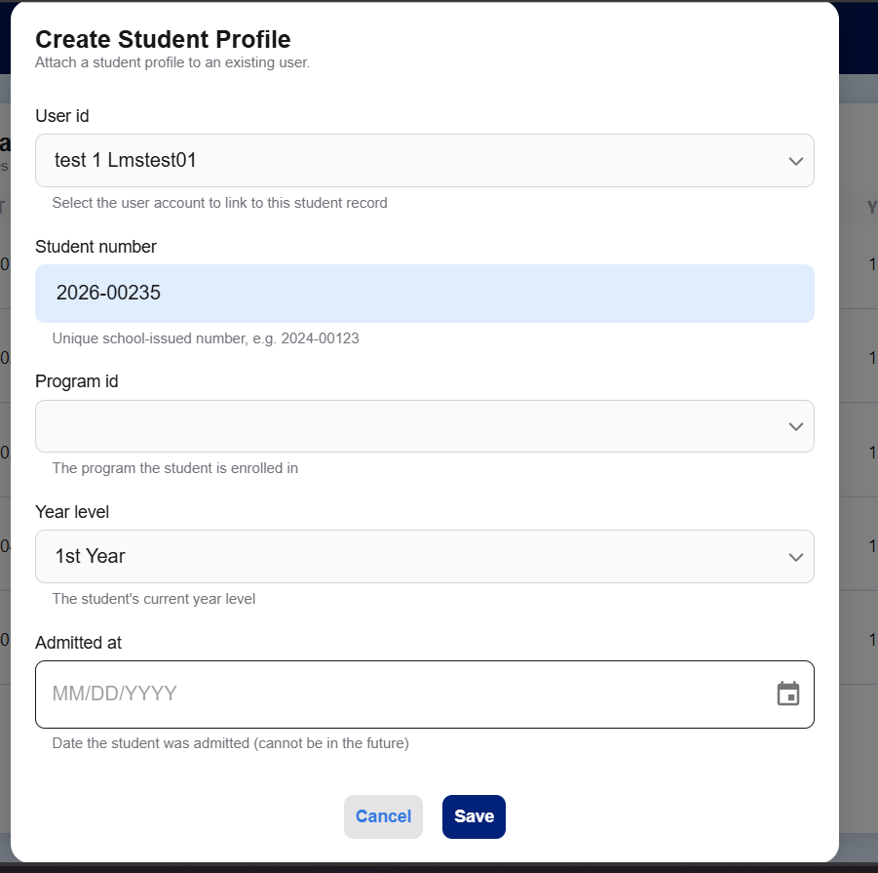

Errors: | Cannot click on the event
Suggestion:
Bug Type: | performance
Module: | events

- Enrollment Management Loading (Severity: )
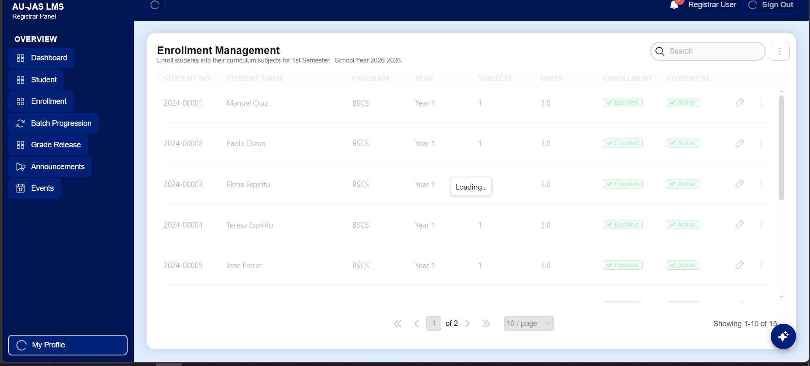

Errors: | It lags so badly. Need to refresh
Suggestion:
Bug Type: | Performance
Module: | Enrollment loading

- Grade Release(Severity: s3 medium )
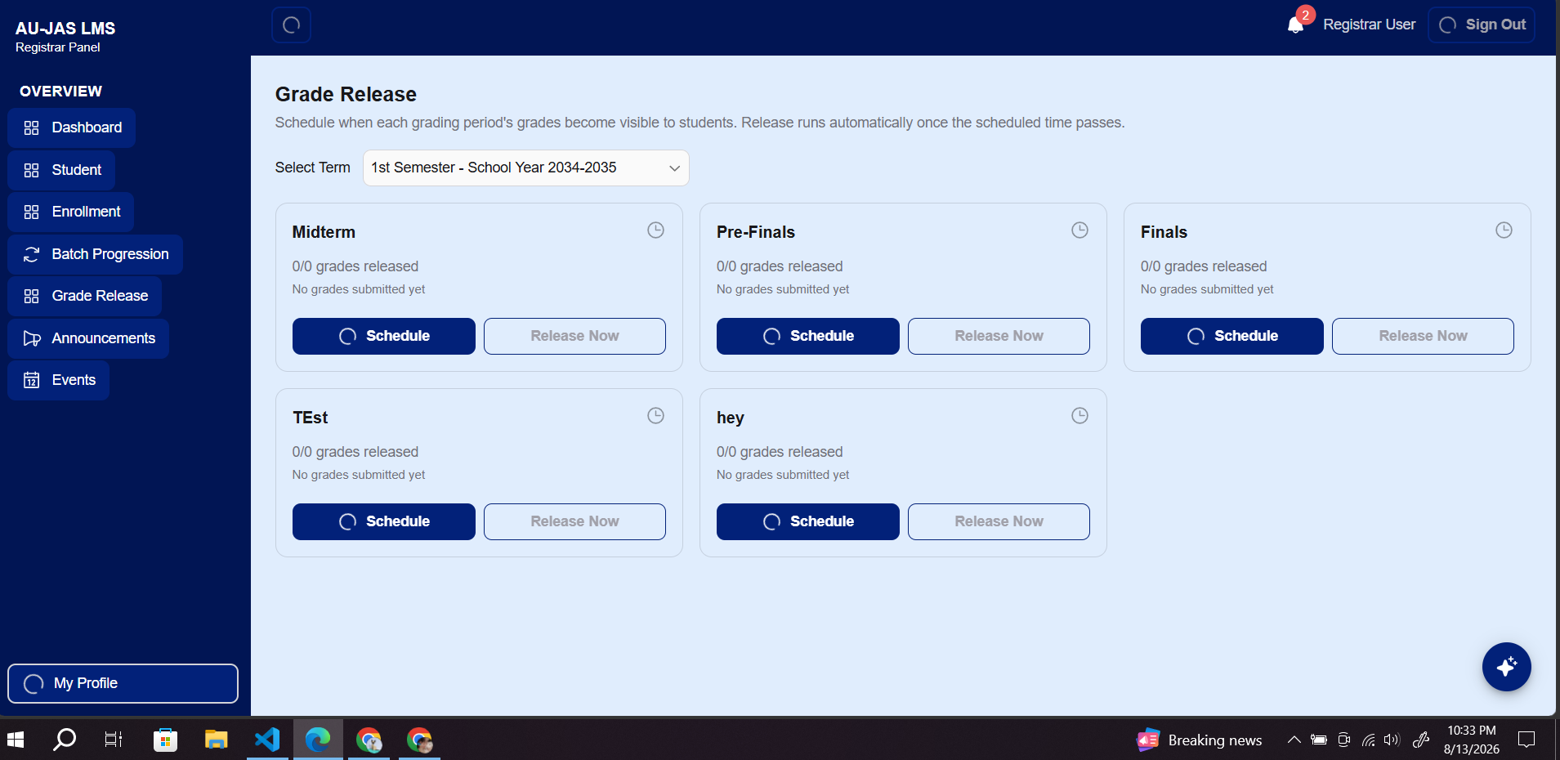

Errors: | Slow
Suggestion:
Bug Type: | Performance
Module: | Grade release

- REGISTRAR ANNOUNCEMENT (Severity: S2 HIGH)
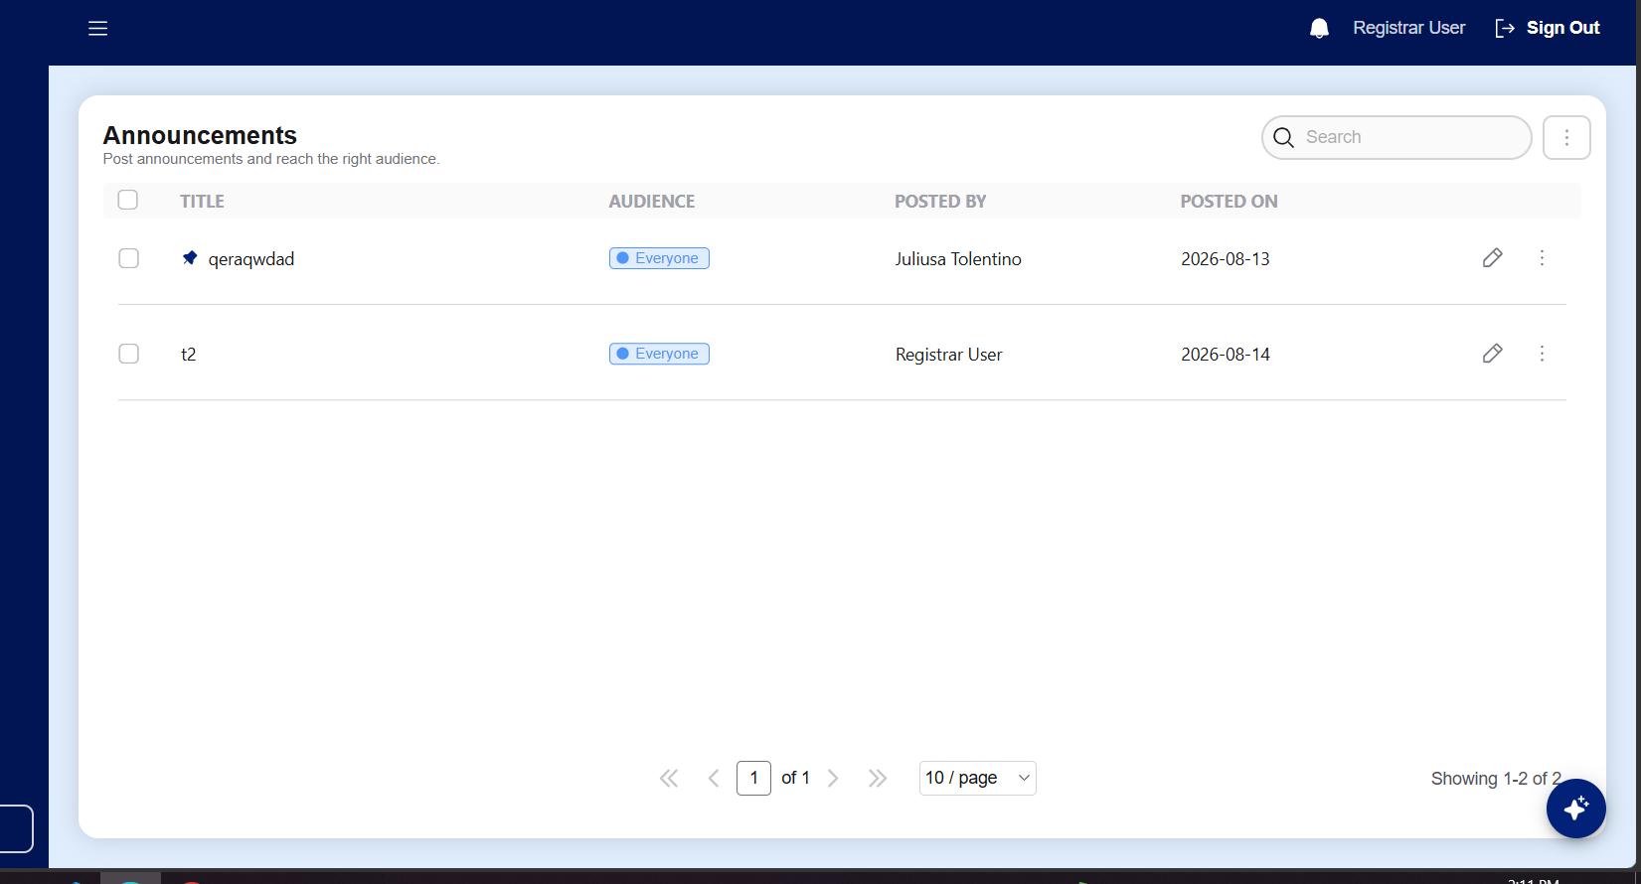

Errors: | It doesn’t show on the dashboard also in other users' dashboard.
Suggestion:
Bug Type: | Functional
Module: | announcement

User Role: Dean - juliustolentino0101@gmail.com

- Dashboard (Severity: s2 high)
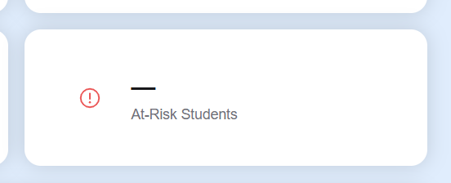
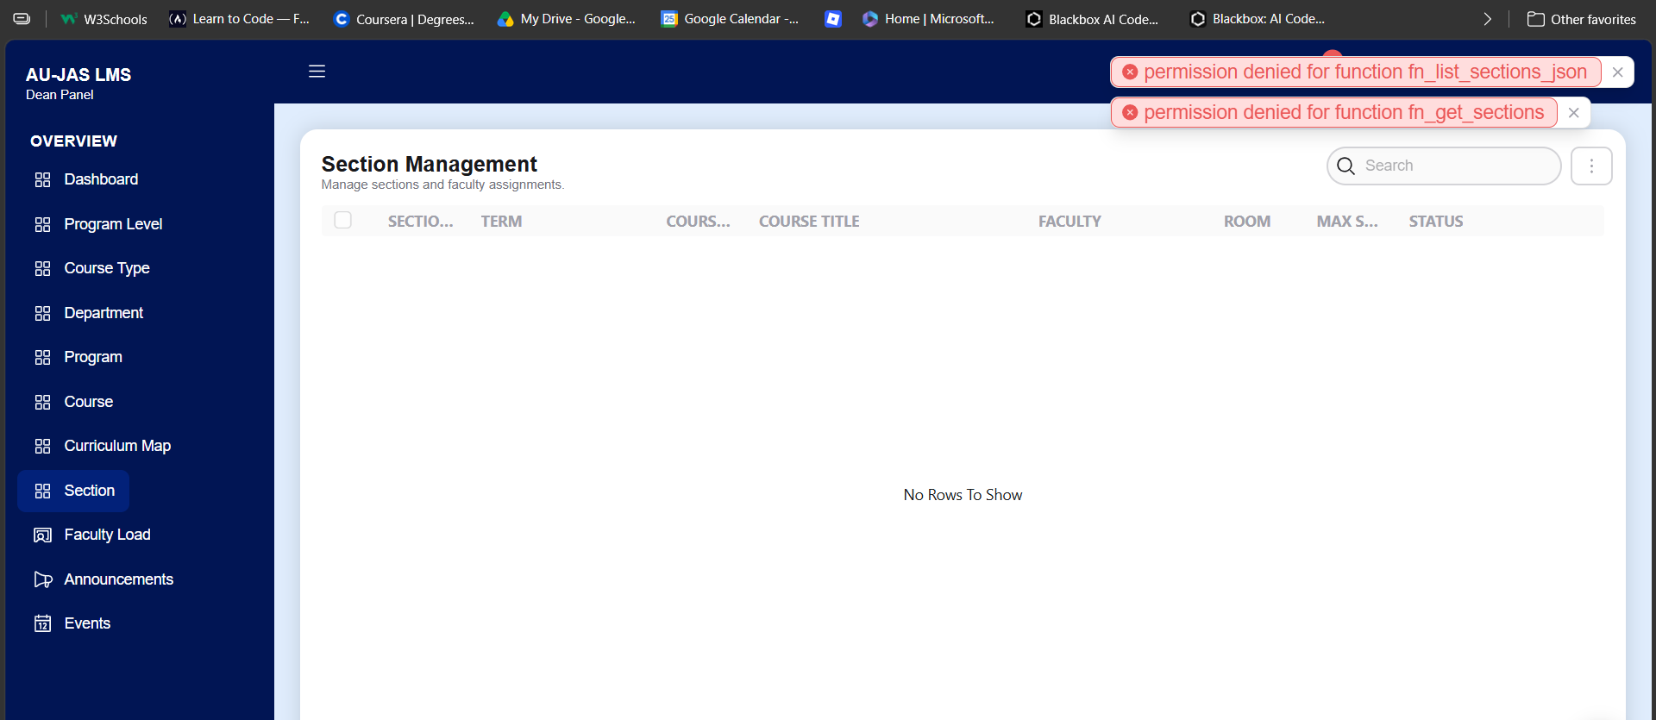

Errors: | .it said permission denied.
Suggestion:
Bug Type:
Module: | School management

- Department (Severity: s4 Low)
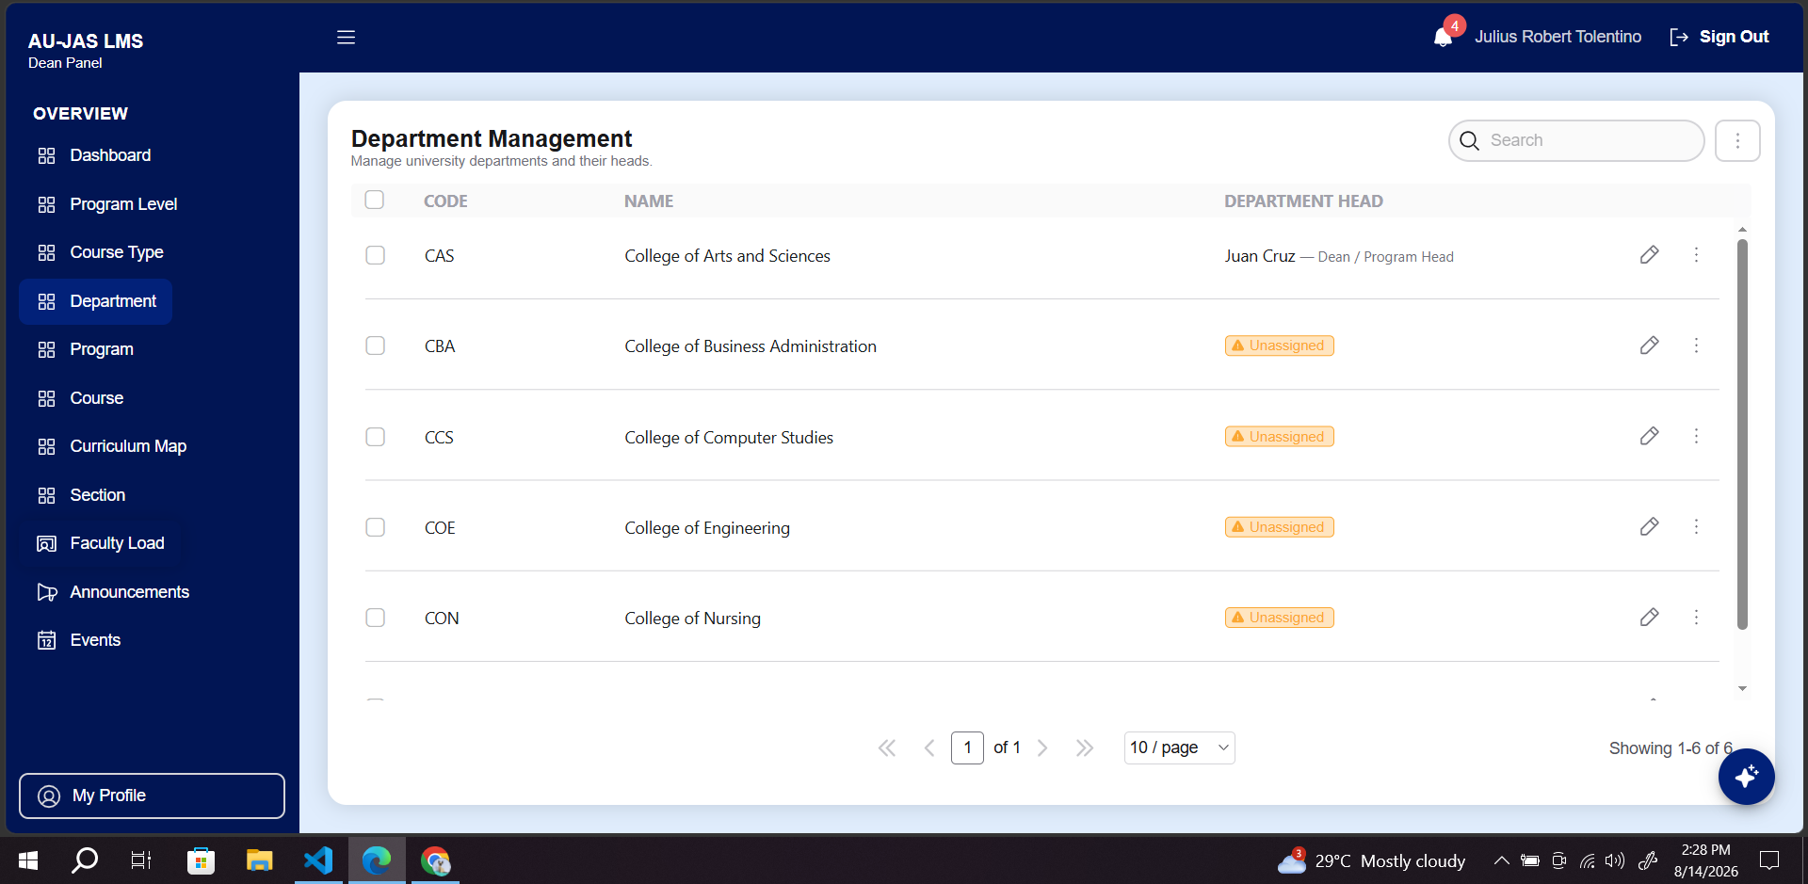

Errors: | I think it's wrong to place it in the dean panel.  Reason: coz its assigned a head department- a dean to be exact and the account is a dean.
Suggestion: | Its should be admin. I think that needs to be placed in the department management.
Bug Type:
Module: | Dept management

- Program (Severity: s1 critical)
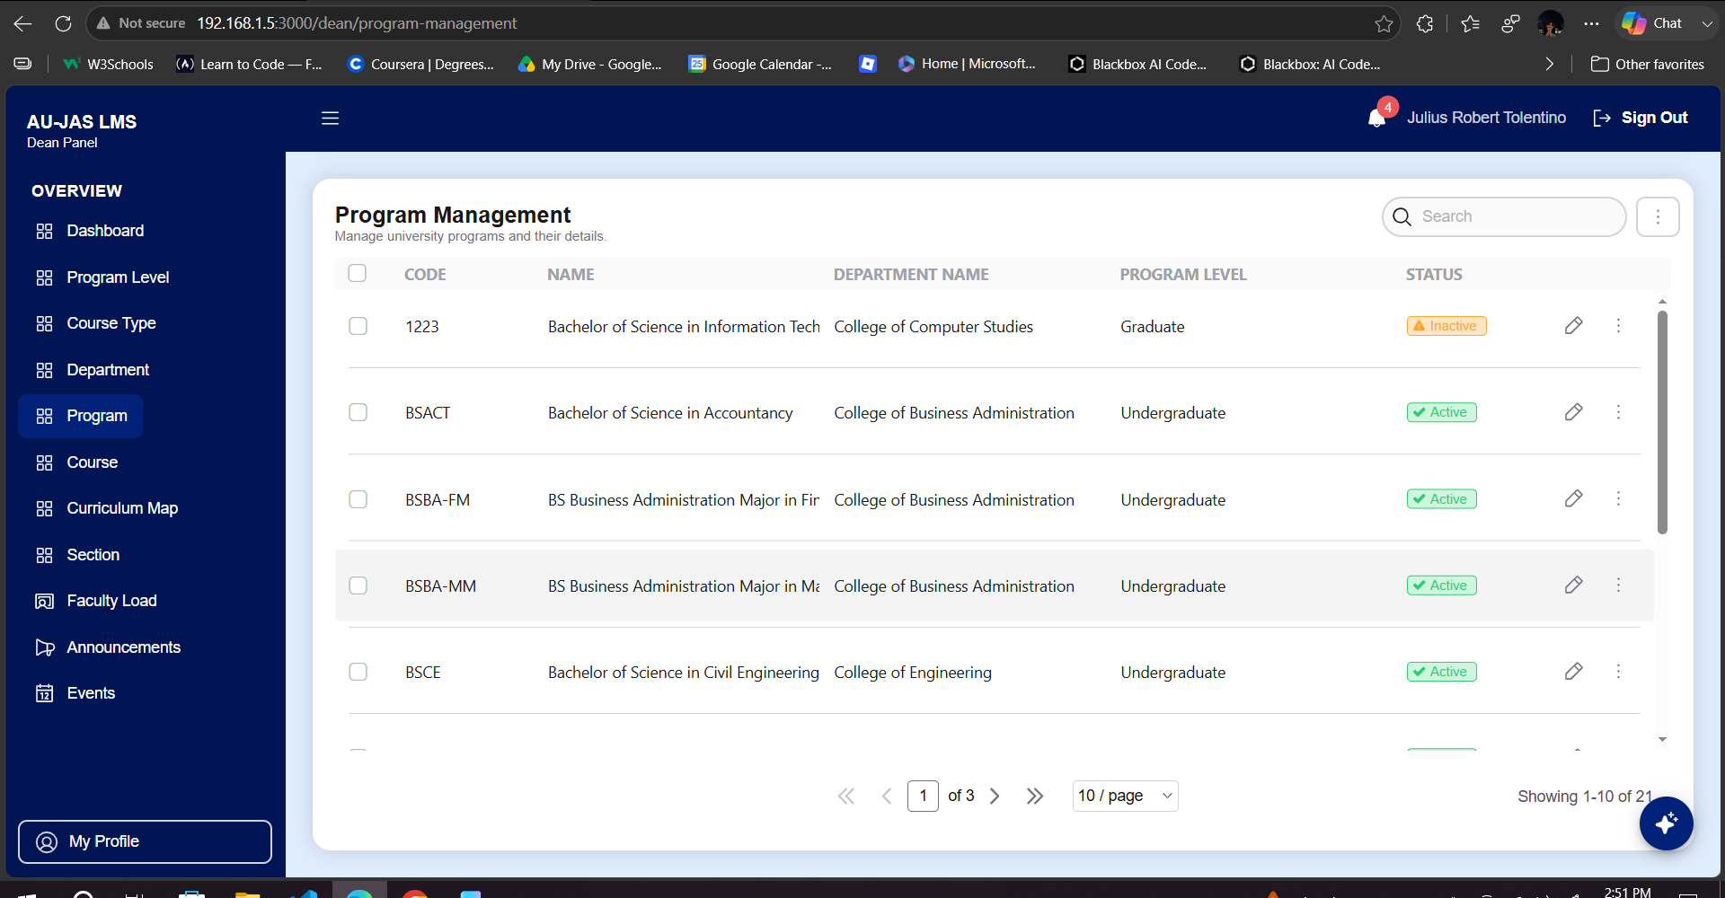

Errors: | .hasn’t change when i tried to edit it.
Suggestion:
Bug Type:
Module:

- Section (Severity: s2 high)
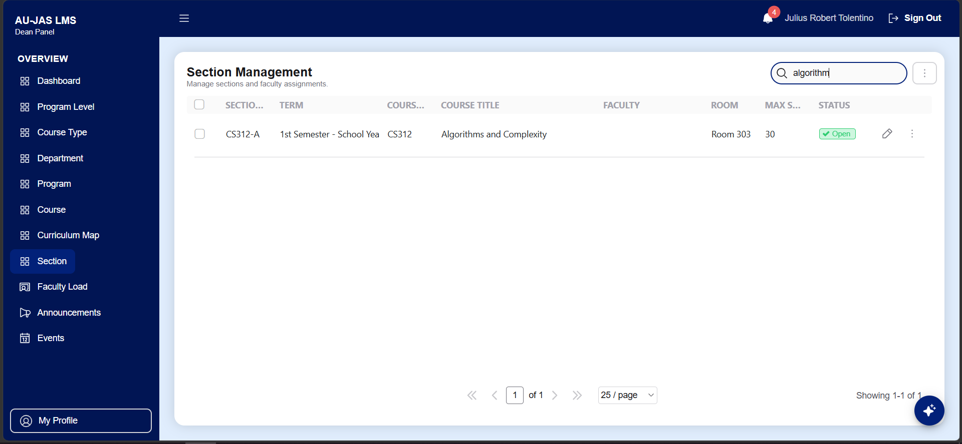
Errors: | It didn’t show the course created.
Suggestion:
Bug Type: | Functional
Module: | section management

- Section (Severity:s1 critical )
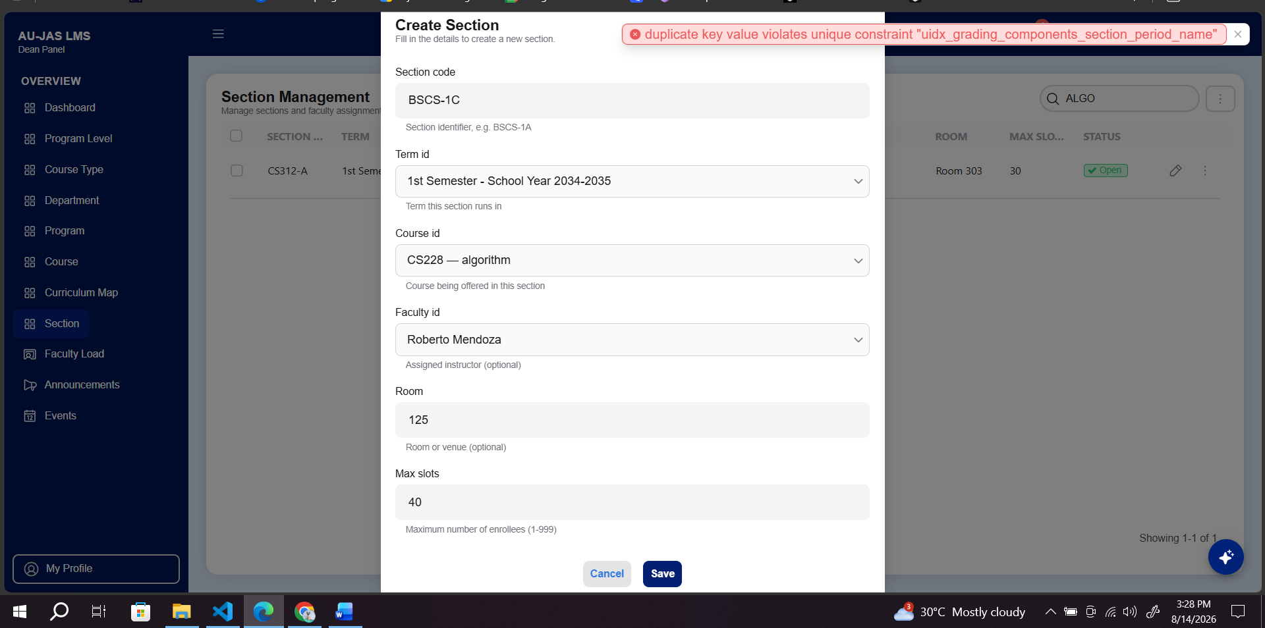

Errors: | It doesn’t show the one i created.
Suggestion:
Bug Type: | Functional
Module: | CREATE SECTION

User Role: Faculty - juliusexample@gmail.com

- (Severity: )

Errors: | .
Suggestion:
Bug Type:
Module:

- Severity: )

Errors: | .
Suggestion:
Bug Type:
Module:

- (Severity: )

Errors: | .
Suggestion:
Bug Type:
Module:

- (Severity: )

Errors: | .
Suggestion:
Bug Type:
Module:

- (Severity: )

Errors: | .
Suggestion:
Bug Type:
Module:

- (Severity: )

Errors: | .
Suggestion:
Bug Type:
Module:

- (Severity: )

Errors: | .
Suggestion:
Bug Type:
Module:

- (Severity: )

Errors: | .
Suggestion:
Bug Type:
Module:

User Role: Student - crowsnight379@gmail.com

- New User login(Severity: )

Errors: | User new log in(created acc) cannot access the lms.
Suggestion:
Bug Type: | Functional
Module: | Log in

- Severity: )

Errors: | .
Suggestion:
Bug Type:
Module:

- (Severity: )

Errors: | .
Suggestion:
Bug Type:
Module:

- (Severity: )

Errors: | .
Suggestion:
Bug Type:
Module:

- (Severity: )

Errors: | .
Suggestion:
Bug Type:
Module:

- (Severity: )

Errors: | .
Suggestion:
Bug Type:
Module:

- (Severity: )

Errors: | .
Suggestion:
Bug Type:
Module:

- (Severity: )

Errors: | .
Suggestion:
Bug Type:
Module:

